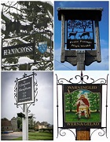
SLAUGHAM PARISH COUNCIL
PLANNING AGENDA
The Committee Members are summoned to a Meeting to be held on
Thursday 14th December 2023
at 5.45pm in the Sports Pavilion, High Street, Handcross
Sally Mclean - Clerk to the Council Email clerk@slaughampc.co.uk Website: http://www.slaughampc.co.uk
The Public and Press are welcome to attend –
The Parish Council is an open and transparent local authority and encourages public attendance at meetings. However, the Council is maintaining COVID precautions. You should not attend a meeting in person if: -
- you have coronavirus symptoms: a high temperature, loss or change to sense of smell or taste, a new continuous cough.
- if you have tested positive for COVID-19 or are waiting for a test result.
- if you have been instructed by the NHS to self-isolate.
- you have recently returned from travel abroad and should be either self-isolating or quarantining.
Keeping us all safe: When you attend the meeting, keep yourself and others safe by following the Government’s guidance at all times.

Present:

- Apologies for absence: To receive and accept apologies for absence.
- Declaration of interest from members in respect of any items on the agenda: To record any declarations of interest
- Approval of the minutes of the last meeting: 26 October 2023, to receive and accept the minutes
- Adjournment for questions from the public: Members to consider adjournment of the meeting in accordance with Council’s Standing Orders, to receive questions from members of the public in attendance in respect of items on the agenda
- To consider the following applications:

DM/23/3015- 22 Horsham Road Pease Pottage Crawley West Sussex RH11 9AL 22 Horsham Road Pease Pottage Crawley West Sussex RH11 9AL
Addition of rear extension and dormer.
Friday 22 Dec 2023
To note any current application for update
- To note planning applications received after the agenda was published:
- To note other planning matters: To include applications consulted under scheme delegation Local Government Act 1972:
  - New planning appeals lodged with the Inspectorate:
  - Planning appeal decisions:
  - Licensing Applications:
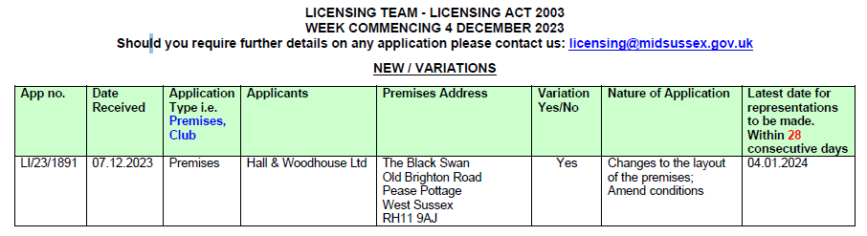
  - Planning Enforcements Updates:

- Mid Sussex District Council DECISIONs cc’d in advance:

- To consider Highways Matters to include but not limited to Public Rights of Way, Bus Stops

- Matters that the Chairmans wish to raise for future consideration:

- Date of the next meeting/s
Signed ___________________________________________ Date: ____________________________________

