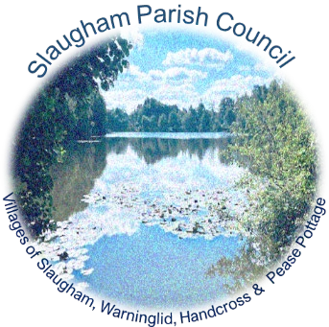
SLAUGHAM PARISH COUNCIL
Parish Council Meeting MINUTES
Thursday 22nd June 2023 7.30pm – The Sports Pavilion, High Street,
Handcross
Sally Mclean - Clerk to the Council Email clerk@slaughampc.co.uk Website: http://www.slaughampc.co.uk
Press and Public are welcome to attend - The Parish Council is an open and transparent local authority and encourages public attendance at meetings. However, the Council is maintaining COVID precautions. You should consider staying at home if: -
- you have coronavirus symptoms: a high temperature, loss or change to sense of smell or taste, a new continuous cough.
- if you have tested positive for COVID-19 or are waiting for a test result.
Keeping us all safe: When you attend the meeting, keep yourself and others safe by following the Government’s guidance at all times.

Present: Cllr’s Julie Elliott, Eric Prescott, Lorette Holborn, Jane MacNaughton, Lesley Read, Bob St George, Phil Morris, Carole Steggles

Others Present: 6 members of public

- Apologies for Absence: To receive and accept apologies for absence. Cllr Gary Marsh, David Dunn

- Declaration of interest from members in respect of any items on the agenda: To record any declarations of interest

- Approval of the Minutes of the Previous Meeting/s held on: To receive and accept the Minutes The Annual Meeting 18th May 2023 Cllrs Bob St George, Lesley Read & The Annual Parish Meeting 25th May 2023 Cllrs Eric Prescott & Lorette Holborn - RESOLVED

- Adjournment for questions from the public: Council to consider adjournment of the meeting in accordance with Council’s Standing Orders, to receive questions from members of the public in attendance in respect of items on the agenda

South East Water Head of Operations for Sussex, Matthew Dean - An opportunity to meet the team behind your water supply and demonstrate the process behind getting water to the taps of your community. CANCELLED

Has a valuer been appointed in relation to the appraisal of the site at St Martins Close under item 6.3 Neighbourhood Planning – Cllr Prescott advised that SPC are waiting to meet with Districts housing officers to determine what the districts requirements are that will determine the full tenure and mix, once this is agreed the valuation can take place.

Is it still the intention of the Council to make the affordable housing for those who have a connection with the parish as originally intended many years ago, which is to meet the needs of the parish, not the district – Cllr Prescott advised that the allocation has to meet with planning policy, SPC need to understand what that is from the district. They are currently unable to commit on what form it will be at this time but will do what they can.
It was anticipated many years ago that as the land is in the ownership of the parish council, housing could be delivered via a medium such as the CLT and that they can choose what is delivered, that you do not have meet the needs of the wider district need - Cllr Prescott advised that they will ask the district to validate this, that the parish do need to ensure that they are compliant with the district and local plan.

- Matters from District & County Councillors: to receive verbal reports from representatives of other authorities
  - Mid Sussex District Council (MSDC): Press Release/s updates cc’d in advance
Cllr Prescott –The Council are reorganising itself with the coalition of parties lots of training taking place for new members.
  - West Sussex County Council County Local Committee (WSCC/CLC) – Press Release/s updates cc’d in advance

- Committee Reports: Council to consider the recommendations, receive and note committee and advisory group/updates: To approve meeting and or briefing notes received in advance of the meeting convened:
  - Finance & Policy Committee: To update members on current activities: To approve meeting/note minutes 13th June 2023 APPROVED
    - To note and approve the effectiveness of the Audit Plan and the Council’s Internal Audit and Internal Control Procedures.
    - Annual Governance Accountability Return (AGAR) 2022/23: The Council to consider and agree that the Annual Governance and Accountability Return for the year ending 31 March 2023 accurately presents the financial management of the Council as required by the Accounts and Audit Regulations 2015 to approve the following:
    - To agree Section 1: The Annual Governance Statement 2022/23 RECOMMENDATION: The Council approve the adoption of the Annual Governance Statement 2022/23. Proposed Cllr Prescott Second Cllr Lorette Holborn APPROVED RESOLVED
    - To agree Section 2: The Accounting Statement 2022/23 RECOMMENDATION: The Council approve the adoption of the Annual Governance Statement 2022/23. Proposed Cllr Prescott Second Cllr Jane MacNaughton APPROVED RESOLVED
    - To agree Internal Auditors Report – noting any findings that require action: RECOMMENDATION The Council approve the adoption of the Internal Auditors Report 2022/23: Proposed Cllr Prescott Second Cllr Bob St George APPROVED RESOLVED
    - To agree the period of the publics’ right of inspection (the Regulations require the period to include 30 workings days and the first ten working days of July) RECOMMENDATION: The Committee agrees to recommend the period of public inspection of the accounts to Council for approval and adoption. Proposed Cllr Prescott Second Cllr Lorette Holborn APPROVED RESOLVED
  - Recreation: To update members on current activities: To approve meeting/note minutes from meeting held:
The Clerk advised that the quotes for the bus shelters have been issued to the Committee for review at their meeting in July and make recommendation to the Council at the next convenient meeting.
The Clerk is working on the allotments and has a meeting with Warninglid Residents Association.
  - Neighbourhood Planning: Land at St Martin Close - To update members on current activities: To approve meeting/note minutes from meetings held: The Neighbourhood Plan indicates that the site is suitable for development – Update members on current progress and future meetings: see item 4
  - Planning Committee: Members to consider updates: To approve meeting minutes of meeting/notes cc’d in advance
The Committee submitted their response to:
Crawley Borough The Local Plan regulation 19 consultation. Information can be accessed online: Local Plan Review | Crawley GOV
Response to the Land at Hyde Lodge, Handcross proposed allocation in the local plan for a specialist elderly accommodation – That proposal is supported in principle by the Parish Council. To confirm that the Council will not support the addition of ‘standard’ residential, affordable housing within the Parish the SNP notes that, having regard to the national and local planning policy background, together with public feedback received during the Neighbourhood Plan making process, the Parish Council “resolved to make housing allocation provision for further, modest housing growth in the parish over the Plan period,” and that this be directed to St Martin Close in Handcross.

- Chairman’s Report: to receive verbal report for the Chair:
Cllr Elliott to organise a meeting with Nymans.

- Clerks Report – to receive verbal or written report from the Clerk papers cc’d in advance
- Investigating a replacement website as the current site is clunky and now dated, she will advise when she has more information on prices and costings.
  - The Clerk is working with Utility Aid through NALC - Utility Aid is the UK's largest energy broker for the not-for-profit sector. This service will manage and maintain the Council’s portfolio, covering procurement, offering a desktop audit to NALC members. The audit will identify any discrepancies on invoices, including:Consumption fluctuations
  - Inaccurate billing - Incorrect VAT - Incorrect tariff - General anomalies

- Finance Matters Payments and receipts The Committee is asked to RESOLVE to approve: Bank Reconciliation for month April & May 2023. Payments 1st June – 22 June (part) cc’d in advance in line with scheme delegation. RECOMMENDATION: The Committee approves the reconciliation/s and schedule of payments: Proposed Cllr Prescott Second Cllr Holborn. APPROVED RESOLVED
Total Payments: 1st June – 22nd June: £11,325.58 VAT £169.69 £11,155.89 APPROVED

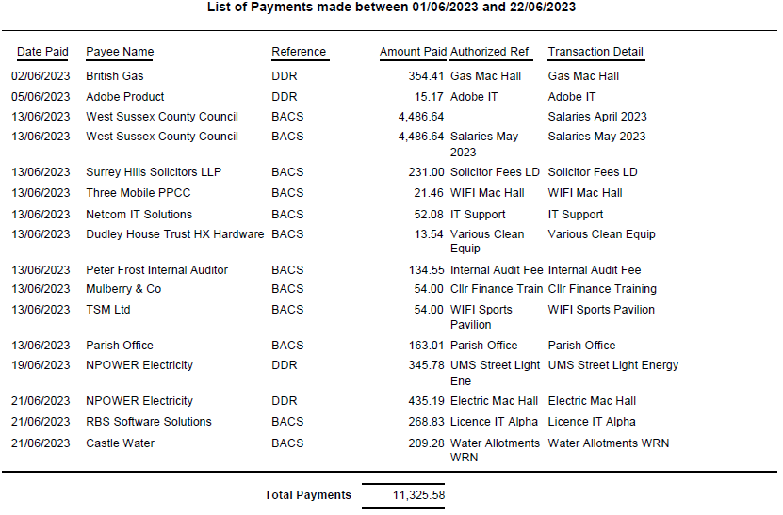

- Correspondence/Information Items/Publications/Consultations: (Correspondence cc’d in advance to members)
  - Handcross Hardware, Community Shop Survey – Cllr Phillip Morris - This is a survey from the Handcross Hardware store to understand more about what people in Handcross and the wider Slaugham parish want from the shops in Handcross and whether there is a need for a community owned general store. The survey can be accessed here or collected from the Hardware Store. The survey closes on the 25th June 2023. The interim results were shared with the Committee. The Clerk advised that there is a nationwide government strategy with funding available to help transform high streets across the UK. There is also S106 developer funds available that can be used to support a scheme https://www.gov.uk/government/news/government-strategy-to-regenerate-high-streets

- Highways/Footpaths: to review highways projects/items
PROW Reports for Slaugham have been circulated to the members in advance:

- Police / NHW Report / Resilience Group Reports
  - Crime Reports cc’d members – Updates issued to members in advance

- Any other matters that the Chairman wishes to raise for future discussion:
  - Pothole reporting system has changed at WSCC.
Meeting closed at 8.30pm
- Date of next meeting/s – 27th July 2023 7.30pm
Signed: Date:

