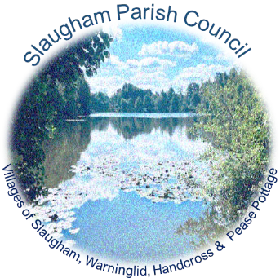

SLAUGHAM PARISH COUNCIL
Parish Council Meeting MINUTES
The Council Members Meeting held on
Thursday 28th March 2024 7.30pm – The Sports Pavilion, High Street, Handcross
Sally Mclean - Clerk to the Council Email clerk@slaughampc.co.uk Website: http://www.slaughampc.co.uk
Press and Public are welcome to attend - The Parish Council is an open and transparent local authority and encourages public attendance at meetings. The Council is maintaining COVID precautions. You should consider staying at home if you have tested positive.
________________________________________________________________________________________________________________________________________________________
Present: Cllrs Julia Elliott, Eric Prescott, Jane MacNaughton, Lorette Holborn, Lesley Read, Phil Morris, Gary Marsh, Adrienne Melville

Others Present: West Sussex County Cllr Bruce Forbes, 2 others

Apologies for Absence: To receive and accept apologies for absence. Cllr Carol Steggles

- Declaration of interest from members in respect of any items on the agenda: To record any declarations of interest. NONE

- Approval of the Minutes of the Previous Meeting/s held on 29th February 2024 -To receive and accept the Minutes. Proposed Cllr Eric Prescott, second Cllr Lorette Holborn

- Adjournment for questions from the public: Council to consider adjournment of the meeting in accordance with Council’s Standing Orders, to receive questions from members of the public in attendance in respect of items on the agenda.

- Matters from District & County Councillors: to receive verbal reports from representatives of other authorities.
  - Mid Sussex District Council (MSDC): Press Release/s updates cc’d in advance.
Finches Field Hemsleys Meadow – Update on the request for the withdrawal of the proposed application linked to the masterplan. The application that was put forward with changes made without consultation received overwhelming objections from the local community and Parish Council. We have been advised that the application has not been withdrawn but will not come before the LPA Committee as the planning officer has further work to do to finalise the report. It is the intention of MSDC to meet with the Parish Council to discuss the application further.
- MSDC Reg 19 – Complete, the responses should be added to the website. Planning Inspectorate hearing scheduled for May/June with adoption planned for November/December.
- Parking Charges – Increase in variable car park charges 10% Burgess Hill, 20% Haywards Heath, 30% East Grinstead with charging for Cuckfield car parking.
- Slaugham Garden Nursery –The owner has been written to tidy up the site. Enforcement are expected to follow this up.
- Slaugham Manor Affordable Housing s106 – Cllr Marsh to contact planning officer for an update.
  - West Sussex County Council County Local Committee (WSCC/CLC) – Press Release/s updates cc’d in advance
- Primary School Handcross – Adjacent property contacted the Parish Council in relation to issues with an extension attached to their property. There is a claim against WSCC for water damage to the neighbouring property following the installation of the new canopy. The officers and surveyors at County are investigating the proposed damage and will respond.

- Committee Reports: Council to consider the recommendations, receive and note committee and advisory group/updates: To approve meeting and or briefing notes received in advance of the meeting convened:
  - Finance & Policy Committee: To update members on current activities: To approve meeting/note minutes from meetings held. Nothing new to add: Finance meeting to be held in April to review the year end AGAR.
  - Recreation: To update members on current activities: To approve meeting/note minutes from meetings held
Allotments have been invoiced for 2022 & 2023; the holders have a deadline of the 28th March 2024. The Clerk will issue reminders in April applying for another 7/10 days at which the Council will renter the sites and reallocate.
  - Neighbourhood Planning: To approve meeting/note minutes from meetings held:
    - Land at St Martin Close - To update members on current activities/status – No new developments at the moment. We've attempted to reach out to Elivia regarding an update on the next steps. The plan is to convene a neighbourhood planning meeting to discuss the next steps so that we can advance the project. A neighbourhood plan review is due but not required until the local plan has been adopted.
  - Planning Committee: Members to consider the following applications: To approve meeting minutes of meeting/notes cc’d in advance.

- Chairman’s Report: to receive verbal report for the Chair:

- Clerks Report – to receive verbal or written report from the Clerk:
  - Adoption of the new Council Communications Committee: The Parish Council, as the primary governing body, has the authority to delegate certain statutory functions to one or more committees or sub-committees. Additionally, for task-focused activities, Working Groups may be established. Parish Council meetings are chaired by the Council's Chair or committee Chair and are supported by a Clerk, responsible for ensuring that all proceedings adhere to legal requirements governing the operation of parish councils.
  - The main distinction lies in the composition: Committees or sub-committees consist solely of council members, whereas Working Groups may include other individuals. While committees must hold regular open sessions allowing public participation, Working Groups do not have delegated responsibilities and are not required to be open to the public. However, their findings and recommendations are presented to the Parish Council for approval. The newly established Communications Group request that the Council approve them as a formal committee with delegated powers. This would enable them to continue to act with those powers on behalf of the Council in matters related to improving communications and further engagement with the local constituency. Proposed Cllr Marsh Second Cllr Prescott APPROVED RESOLVED
  - Communications Working Group: To consider and approve meeting minutes notes 12th March 2023 and 21st March 203 cc’d in advance. The team will distribute the planned newsletter and survey prior to the APM on April 18th. Cllr Prescott inquired about whether the survey is gathering data, to which the Clerk clarified that the survey focuses on communication aspects, with no current plans to gather contact information. Additionally, the team has identified a leading website, Aubergine, with whom they plan to meet to finalise certain questions and present them at the upcoming meeting.
Proposed Cllr Marsh Second Cllr Prescott APPROVED RESOLVED
  - Members are asked to review and adopt the new terms of reference and delegated powers for the formal adoption of the Communications Working Group as a lawfully approved Committee of the Parish Council (Local Government Act 1972) cc’d in advance Proposed Cllr Marsh Second Cllr Prescott APPROVED RESOLVED

- Finance Matters:
  - Payments and receipts The Committee is asked to RESOLVE to approve: Bank Reconciliation for month February 2024 Approval in line with scheme delegation (Ref: Bank Payment November part cc’d in advance) RECOMMENDATION: The Committee approves the schedule of payments for 28th February – 28th March 2024 previously distributed. Proposed Cllr Morris, Second Cllr Melville

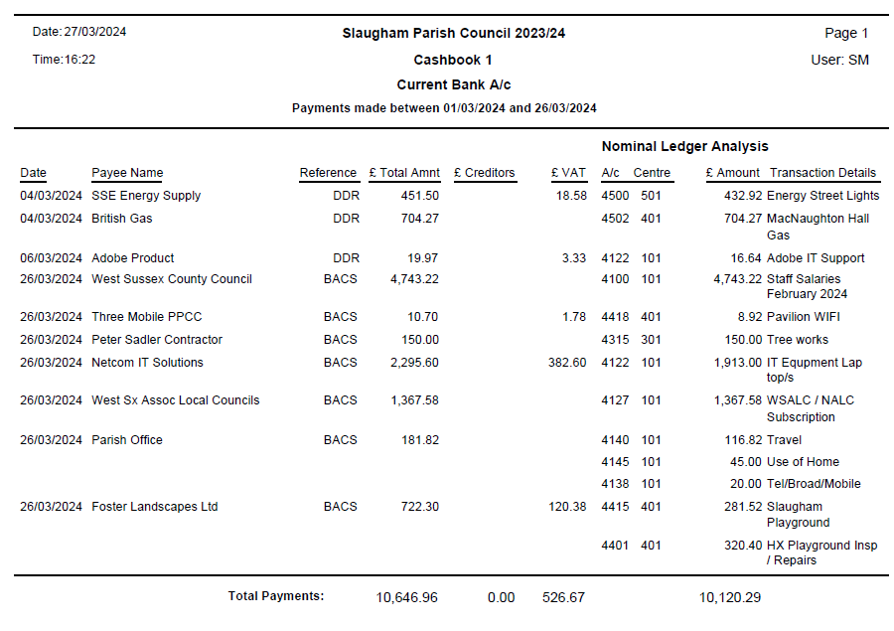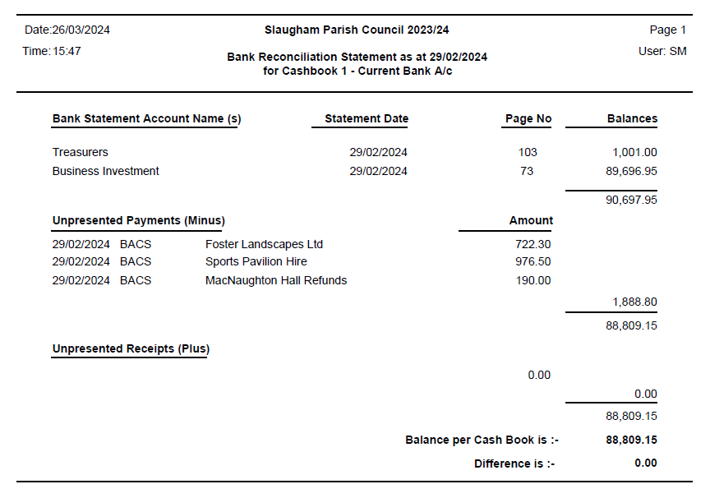

- Correspondence/Information Items/Publications/Consultations: (Correspondence cc’d in advance to members)

- Highways/Footpaths: to review highways projects/items: To update members of the following:

Police / NHW Report / Resilience Group Reports
  - Crime Reports cc’d members – Updates issued to members in advance.

Any other matters that the Chairman wishes to raise for future discussion:

- Date of next meeting/s – 25th April 2024

Signed: Date:

