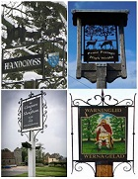
SLAUGHAM PARISH COUNCIL
PLANNING AGENDA
The Committee Members held a Meeting on
Thursday 14th December 2023
at 5.45pm in the Sports Pavilion, High Street, Handcross
Sally Mclean - Clerk to the Council Email clerk@slaughampc.co.uk Website: http://www.slaughampc.co.uk
The Public and Press are welcome to attend –
The Parish Council is an open and transparent local authority and encourages public attendance at meetings. However, the Council is maintaining COVID precautions. You should not attend a meeting in person if: -
- you have coronavirus symptoms: a high temperature, loss or change to sense of smell or taste, a new continuous cough.
- if you have tested positive for COVID-19 or are waiting for a test result.
- if you have been instructed by the NHS to self-isolate.
- you have recently returned from travel abroad and should be either self-isolating or quarantining.
Keeping us all safe: When you attend the meeting, keep yourself and others safe by following the Government’s guidance at all times.

Present: Cllr E Prescott (Chair), L Read, B Dt George, K Boyle, L Holborn.

- Apologies for absence: To receive and accept apologies for absence. None
- Declaration of interest from members in respect of any items on the agenda: None
- Approval of the minutes of the last meeting: 26 October 2023, Proposed K Boyle. Seconded, L Read.
- Adjournment for questions from the public: Members to consider adjournment of the meeting in accordance with Council’s Standing Orders, to receive questions from members of the public in attendance in respect of items on the agenda. No one present.
- To consider the following applications:

DM/23/3015- 22 Horsham Road Pease Pottage Crawley West Sussex RH11 9AL 22 Horsham Road Pease Pottage Crawley West Sussex RH11 9AL
Addition of rear extension and dormer. SPC, no objection. Concern was raised at the reduction of off road car-parking since the last application.
To note any current application for update
- To note planning applications received after the agenda was published:
- To note other planning matters: Application: DM/23/2398, Land to the west of London Rd, Handcross, was called in by Cllr Prescott and following review by the MSDC Planning committee. Planning permission was refused as the proposal would have damaged the natural beauty of the High Weald contrary to Policy DP16 of the mid Sussex District Plan and Policy 1 of the Slaugham Neighbourhood plan.
  - New planning appeals lodged with the Inspectorate:
  - Planning appeal decisions:
  - Licensing Applications:
SPC have considered the proposal below and have no comment or objections.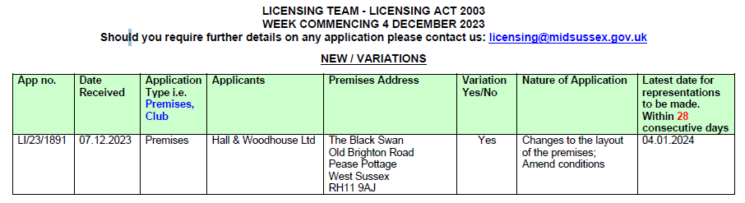
  - Planning Enforcements Updates

- Mid Sussex District Council DECISIONs cc’d in advance:

- To consider Highways Matters to include but not limited to Public Rights of Way, Bus Stops

- Matters that the Chairmans wish to raise for future consideration:

- Date of the next meeting/s
Signed ___________________________________________ Date: ____________________________________

